Name: Poorab Gangwani

Section: 2B1

Enrollment #: CS191092

**LAB # 12**

**Bipolar Junction Transistor (BJT) Characteristics**

**Lab Objectives:**

* To study the Bipolar Junction Transistor (BJT) and its mode of operation
* To experimentally verify the output Characteristics of BJT

**Apparatus Required:**

* Transistor 2N3904 (NPN)
* Resistors
* Bread-board
* Variable power supply
* Multi-meter

**PRE-LAB**

**Bipolar Junction Transistor:**

Unlike resistors, which impose a linear relationship between current & voltage, transistors are non-linear devices. They have four distinct modes of operation, which describe the current flowing through them. The **operational mode** of the BJT depends on how the junctions between the regions are biased. Since there are two junctions, the **emitter-base junction** (EBJ) and the **collector-base junction** (CBJ), and each of these junctions may be either forward- or reverse-biased, the three useful modes of operation are

|  |  |  |
| --- | --- | --- |
| **MODE OF OPERATION** | **EBJ** | **CBJ** |
| Active (or Forward Active) | Forward biased | Reverse biased |
| Cutoff | Reverse biased | Reverse biased |
| Saturation | Forward biased | Forward biased |

1. **Saturation** – The transistor acts like a **short circuit**. Current freely flows from collector to emitter.
2. **Cut-off** – The transistor acts like an **open circuit**. No current flows from collector to emitter.
3. **Active** – The current from collector to emitter is **proportional** to the current flowing into the base.

The BJT is constructed with three doped semiconductor regions separated by two PN junctions as shown in the epitaxial planar structure in FIGURE 12.1(a). The three regions are called emitter, base and collector. The middle region is called the base and the outer two regions are called emitter and the collector. Physical representations of the two types of BJTs are shown in FIGURE 12.1(b) & (c). One type consists of two n-regions separated by p-region (NPN), and the other type consists of two p-regions separated by n-region (PNP).

*Fig. 12.1: Construction and representation of bipolar junction transistor*

In most transistors, emitter is heavily doped. Its job is to emit or inject electrons into the base. The base is lightly doped and very thin, it passes most of the emitter-injected electrons on to the collector. The doping level of collector is intermediate between the heavy doping of emitter and the light doping of the base. The collector is so named because it collects electrons from base. The collector is the largest of the three regions; it must dissipate more heat than the emitter or base. And the base is smallest.

FIGURE 12.2 shows the schematic symbol for the NPN and PNP bipolar junction transistors. The term bipolar refers to the use of both electrons and holes as carriers in the transistor structure



*Fig. 12.2: Transistor symbol*

A DMM can also be used to check the terminals of transistors if not known and no datasheets are available. To check the terminals first determine the forward resistance of base-collector junction and base-emitter junction and note it down. Recall that collector is lightly doped then emitter therefore, the forward resistance of base-collector junction is lower than base emitter junction.

**Transistor Collector Characteristics Curve:**

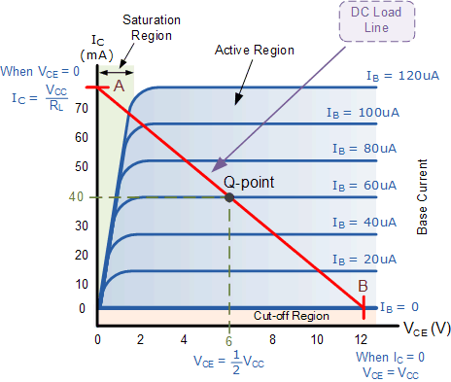

*Fig. 12.3: Transistor collector characteristic curve*

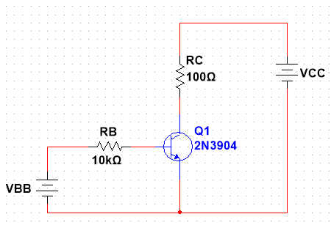

*Fig. 12.4: Transistor circuit for characteristic curve*

**LAB TASK 1:**

1. Develop the circuit of **fig. 12.4** on bread board.
2. Firstly, set VCC = 0, Increase the voltage VBB until a current IB = 20µA flows in the base of transistor. Now set VCC according to table 12.1 and measure IC and VCE.
3. Repeat step 2 for all currents of IB and fill up table 12.1.
4. Measure **IC** in mA and **VCE** in Volts.
5. Using the data recorded in **table 8.2**, plot V-I characteristics graph between VCE and IC.

*Table 12.1: In-lab task 1 transistor collector characteristics curve*

|  |  |  |  |  |  |  |  |  |
| --- | --- | --- | --- | --- | --- | --- | --- | --- |
|  | IB = 20 µA | | IB = 40 µA | | IB = 60 µA | | IB = 80 µA | |
| VCC | IC | VCE | IC | VCE | IC | VCE | IC | VCE |
| 0.5 | 1.231mA | 0.376V | 3.262mA | 0.173V | 3.582  mA | 0.141V | 3.719  mA | 0.128V |
| 1 | 1.239mA | 0.876V | 4.243mA | 0.575V | 7.339  mA | 0.266V | 8.188  mA | 0.181V |
| 2 | 1.256mA | 1.874V | 4.3mA | 1.57V | 7.516  mA | 1.248V | 10.706  mA | 0.929V |
| 4 | 1.289mA | 3.871V | 4.414mA | 3.559V | 7.716  mA | 3.228V | 10.991  mA | 2.901V |
| 6 | 1.322mA | 5.868V | 4.528mA | 5.547V | 7.915  mA | 5.208V | 11.275  mA | 4.872V |
| 8 | 1.355mA | 7.864V | 4.643mA | 7.536V | 8.115  mA | 7.188V | 11.56  mA | 6.844V |
| 10 | 1.389mA | 9.861V | 4.757mA | 9.524V | 8.315  mA | 9.169V | 11.843  mA | 8.816V |

**Conclusion:**

**__________________________________________________________________**

**__________________________________________________________________**

**__________________________________________________________________**

**__________________________________________________________________**

Name: Poorab Gangwani

Enrollment #: CS191092

**POST-LAB ASSIGNMENT # 12**

**Task 1:** What is βDC in transistors?

It is the ratio of the DC collector current to the DC base current and is the DC current gain of a transistor.

**Task 2:** Read the datasheet of transistor 2N3904 and list some of the absolute maximum ratings given in the datasheet.

Highest rating in I b of 20ua is 9.861V in Vce and 1.389mA in Ic.

Highest rating in Ib of 40ua is 9.524V in Vce and 4.757mA in Ic.

Highest rating in Ib of 60ua is 9.169V in Vce and 8.315mA in Ic.

Highest rating in Ib of 80ua is 8.816V in Vce and 11.843

mA in Ic.